**ACS 2913 – SOFTWARE REQUIREMENTS ANALYSIS AND DESIGN**

ASSIGNMENT 4

*DAMILARE ALESHINLOYE: 3099949*

*AVISHEK RAJ: 3107155*

*ANUOLUWAPO OYAFUNKE: 3092896*

(1).

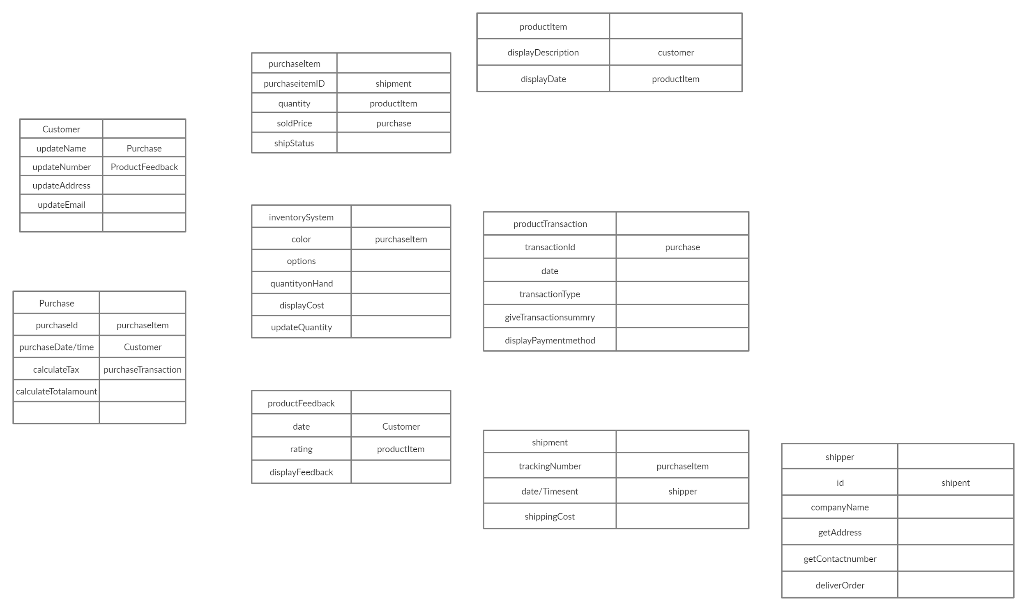

SET OF CRC CARDS

(2). DESIGN CLASS DIAGRAM WITH ALL METHOD SIGNATURES

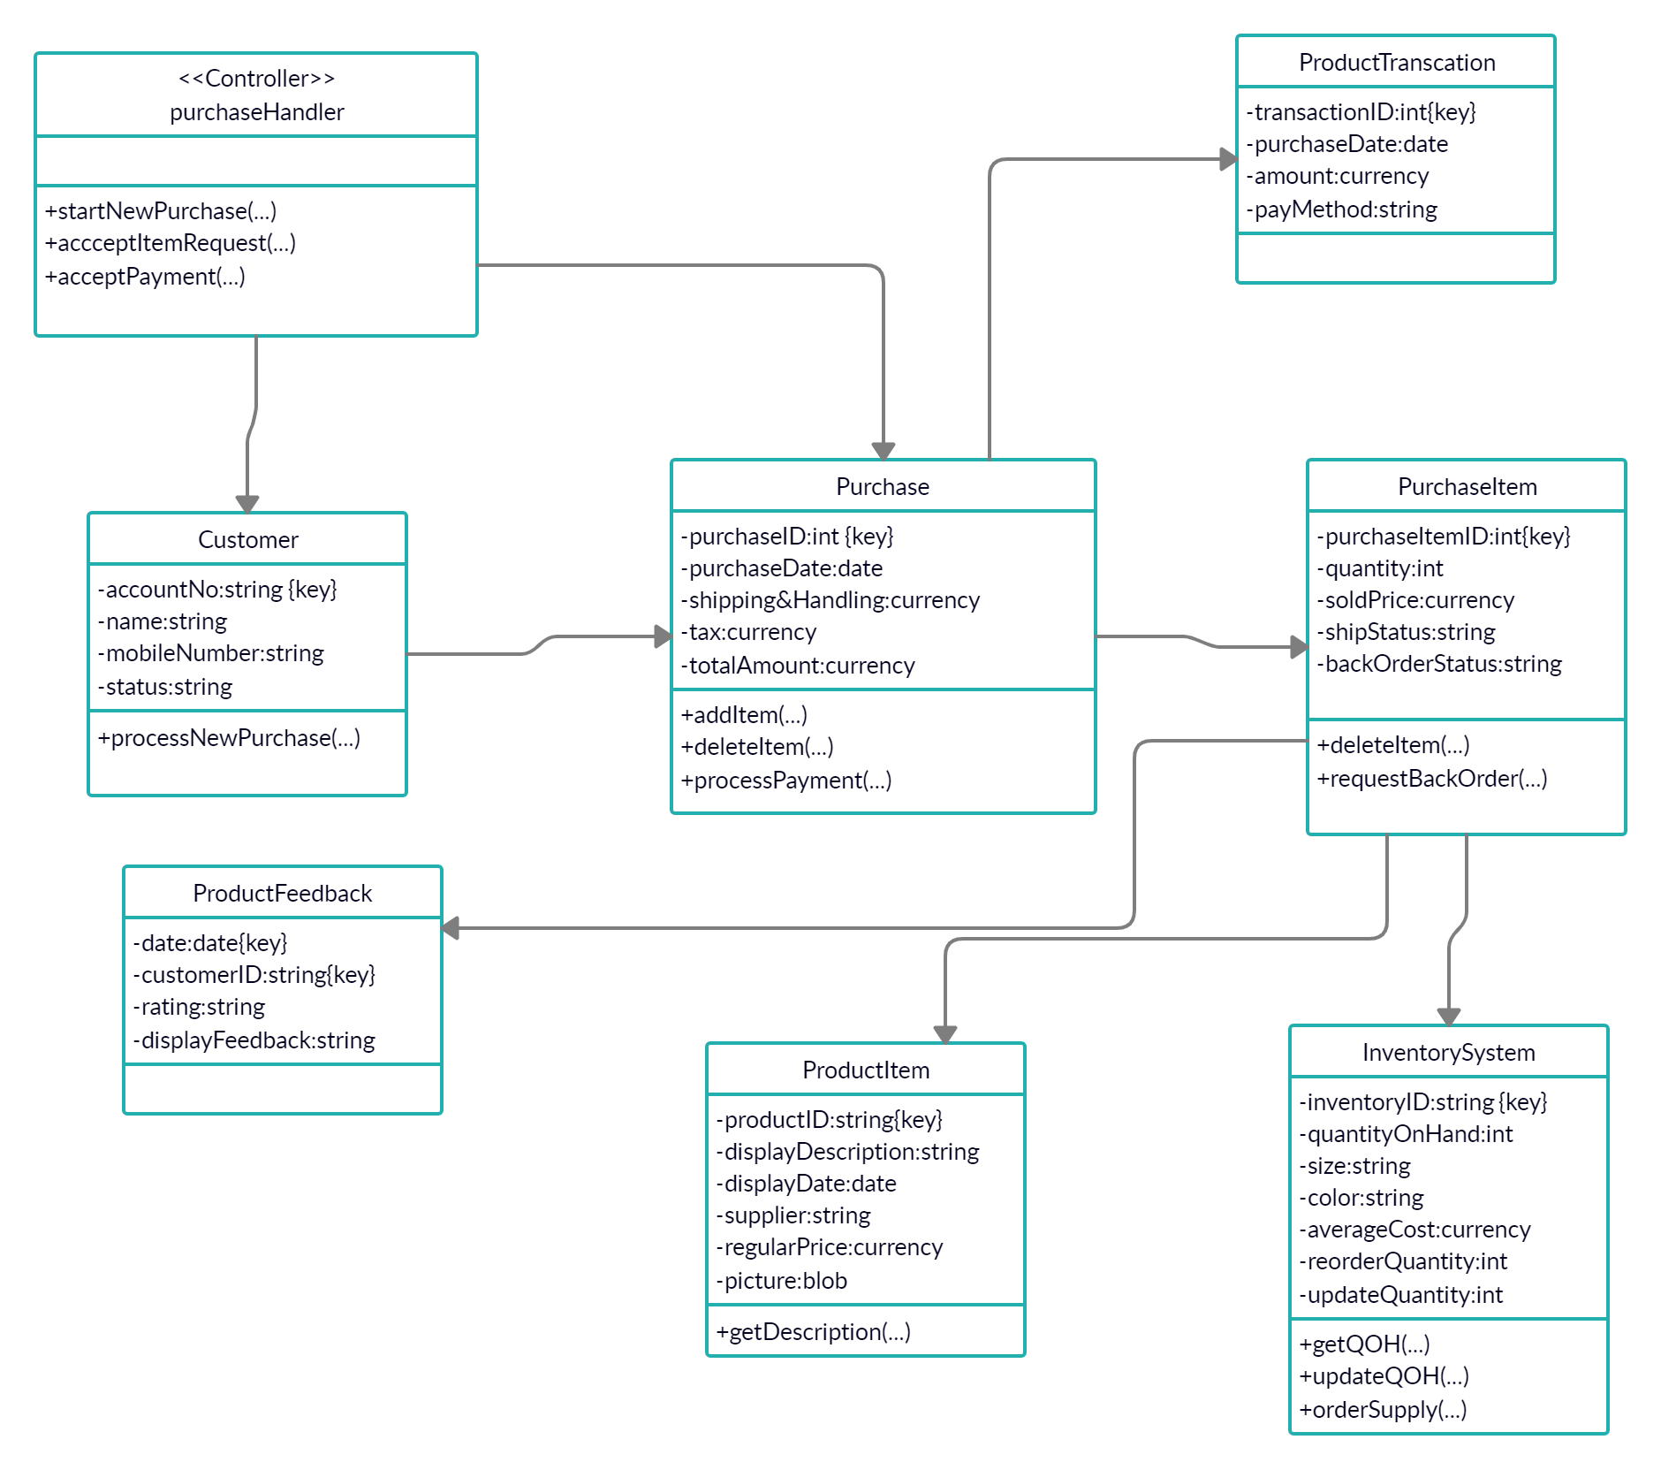

(3).

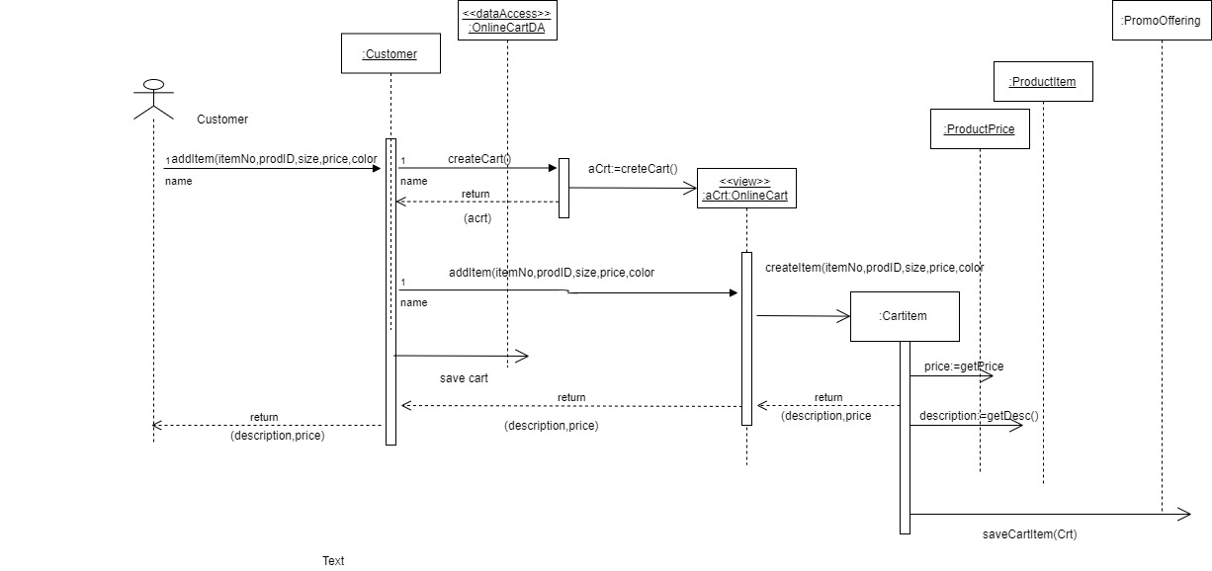

SEQUENCE DIAGRAM FOR THE USE CASE “ADD TO CART”

(4).

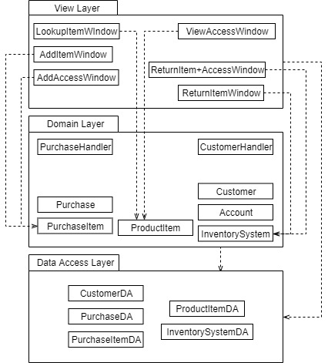

CLASS PACKAGE DIAGRAM